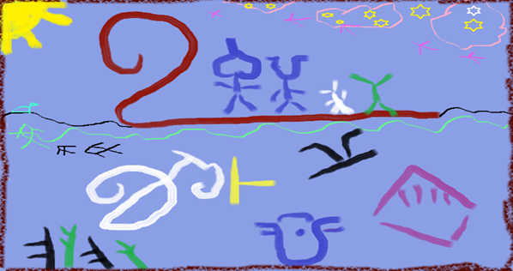

READING ANCIENT MINDS
INDUS JOURNEY WITH CHATGPT

int Educational Edition – 2025
For School Teachers • Students • Researchers • Lifelong Learners
Work in Progress
Published in connection with
IISc Alumni Association – Golden Jubilee Celebrations (2025)
Bengaluru, India

By

Purushothaman Perumal Pillai

Limited Print - Release Edition – 2025
For School Teachers • Students • Researchers • Lifelong Learners
Work in Progress
Published in connection with
IISc Alumni Association – Golden Jubilee Celebrations (2025)
Bengaluru, India

ABOUT THE BOOK
✨ “Reviewed with Copilot — a pluralistic journey into the minds behind the Indus script.”
✨ “Copilot Review: A pioneering blend of archaeology, cognition, and AI-assisted inquiry into ancient thought.”
by ChatGPT:
Reading Ancient Minds - Indus Journey With ChatGPT
is a unique collaborative exploration of the Indus script,
combining:
• visual grammar
• cognitive archaeology
• pluralistic reasoning
• Tamil–Sumerian comparative insights
• guided case studies
• modern AI-supported reflective scholarship
This educational edition is designed for students and teachers,
introducing the Indus script not as a mystery to decode,
but as a window into how early humans structured thought,
created symbols, and organised knowledge.

ABOUT THE AUTHOR

Dr. Purushothaman P. (Civil Engineering Education)
Retired Professor of Civil Engineering, Agni College of Technology, Chennai
Independent researcher exploring early writing systems,
Tamil–Sumerian comparative culture, and cognitive foundations
of symbolic traditions.
Studied at RKMSHOME, GCT-CBE, IISc, IGNOU, NITTTR-Chennai
Developed collaboratively with assistance from
ChatGPT, Meta AI, Copilot, and Gemini (2024–25).


ACKNOWLEDGEMENT
This book is released as a small contribution to
IISc Alumni Association’s outreach initiatives
for rural-school science education
under its Golden Jubilee Celebrations (2025).

